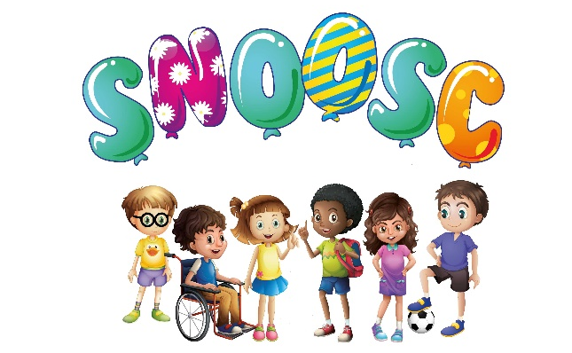

S.N.O.O.S.C.

S.N.O.O.S.C.

INTIMATE CARE POLICY

SNOOSC is committed to ensuring that all staff responsible for the intimate care of children/young adults will undertake their duties in a professional manner at all times. SNOOSC recognises that there is a need to treat all children/young adults with respect when intimate care is given. No child/young adult should be attended to in a way that causes distress or pain.
OUR APPROACH TO BEST PRACTICE:
The management of all children/young adults with intimate care needs will be carefully planned. The child/young adult who requires intimate care is treated with respect at all times. The child’s/young adult’s welfare and dignity is of paramount importance.
Staff who provide intimate care are trained to do so (including Child Protection and Health & Safety training in lifting and moving) and are fully aware of best practice. Apparatus will be provided (a hoist, and a bed) to assist with children/young adults who need special arrangements following assessment and during SNOOSC risk assessment as required. Staff will be supported to adapt their practice in relation to the needs of individual children/young adults taking into account developmental changes such as the onset of puberty.
The child/young adult will be supported to achieve the highest level of autonomy that is possible within their disabilities range. Staff will encourage each child to do as much for him/herself as he/she can. This may mean, for example, given the child responsibility for washing themselves. Individual intimate care plans can be drawn up for particular children as appropriate to suit the circumstances of the child.
Each child’s/young adults right to privacy will be respected. Careful consideration will be given to each child’s/young adult’s situation to determine how many staff might need to be present when a child is toileted. Where possible one child/young adult unless there is a sound reason for having more adults present. If this is the case, the reasons should be clearly documented.
Wherever possible the same child/young adult will not be cared for by the same adult on a regular basis, ideally there will be a rota of staff known to the child/young adult who will take turns in providing care. This will ensure, as far as possible, that over-familiar relationships are discouraged from developing, whilst at the same time guarding against the care being carried out by a succession of completely different staff.
No Buddies up to the age of 18 will be required to complete any role or responsibility towards Intimate Care. Upon reaching the age of 18, they will be invited to have a Development Appraisal with the Manager, to discuss this role, and the training needed towards this responsibility.
Wherever possible staff should only care intimately for an individual of the same sex. However, in certain circumstances this principle may be waived, and in SNOOSC organisation NO males should care for a female child/young adult, although a female staff member may care for a male child/young adult. This, however may be waived where failure to provide appropriate care would result in negligence.
Intimate care arrangements will be discussed with parents/carers on a regular basis and recorded. The needs and wishes of child/young adults and parents/carers will be taken into account wherever possible within the constraints of staffing and equal opportunities legislation.
THE PROTECTION OF CHILD/YOUNG ADULT:
Child Protection Procedures and Inter-Agency Child Protection procedures will be adhered to.
If a member of staff has any concerns about physical changes in a child’s/young adult’s presentation, e.g. marks, bruises, soreness etc she/he will immediately report concerns to the Team Leader/Deputy Team Leader.
If a child/young adult becomes distressed or unhappy about being cared for by a particular member of staff, the matter will be looked into and outcomes recorded. The Team Leader/Deputy Team Leader must be made aware of any distress occurring. Staffing rotas will be altered until the issue(s) are resolved so that the child/young adult needs remain paramount
If a child/young adult makes an allegation against a member of staff, all necessary procedures will be followed.
Intimate care is any care which involves washing, touching or carrying out an invasive procedure (such as cleaning up a club member after they have soiled themselves) and including nappy changing to intimate personal areas. In most cases such care will involve cleaning for hygiene purposes as part of a staff member’s duty of care.
The issue of intimate care is a sensitive one and will require staff to be respectful of the child/young adults needs. The child/young adults’ dignity should always be preserved with a high level of privacy. There shall be a high awareness of child protection issues. Staff behaviour must be open to scrutiny and staff must work in partnership with parents/carers to provide continuity of care to children/young adults wherever possible and practicable.
Policy referenced with Health & Hygiene/Safeguarding/Health & Safety/Safeguarding/Child protection/Admission Policies:
Policy reviewed March 2022:
This Policy to be reviewed March 2024:

