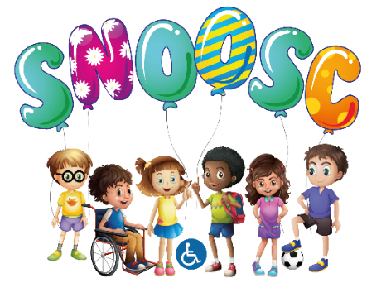

ADMISSIONS POLICY

S.N.O.O.S.C.

Special Needs Out Of School Club welcomes children from all backgrounds, regardless of their ethnicity, culture, or religion, home language, family background, learning difficulties, or disabilities, gender or ability and we seek to avoid any form of discrimination on all levels.
We welcome children with SEND or requirements, providing the facilities that can be practically arranged to provide a safe, stimulating environment for all the children, and those with Special Needs can cope within our setting.
SNOOSC (IN BEDS) welcomes children between the ages of 8 - 25 years of age.

REGISTRATION:
When an enquiry/referral/signposted regarding places is made, Parents/Carers will be given a Starter Pack, and all relevant club information.

Information regarding availability of places:
Details of Admission and Fees:
Charging/Cancellation Policy:
Registration form:
Medication Forms:

Current contact details:

Behaviour management policy:

Compliments & Complaints Policy:
Permission for videos/photography, social media:
SNOOSC Safety Plan:
Admissions Policy:
All referrals whether this is a direct referral by the Family, or through the Local Authority or any other agency – there is a requirement by the SNOOSC Organisation to invite the Family or their designated approved representative to attend a meeting prior to acceptance. This will include information regarding the young person’s Disability/Behaviours, to be shared with all and included within the SNOOSC Safety Plan.
The SNOOSC Organisation reserves the right to either accept or decline any referral dependant on information shared.
These will be sent to Parents/Carers for updating on a 6 monthly timescale:

If places are limited our admission priorities are:
Siblings (should they have the requirements for access to the organisation):
Chronological order of first application:

SNOOSC will work closely in partnership with Parents/Carers in caring and nurturing and making a safe and happy environment for your child. Our staff will have both the time and the training to welcome Parents/Carers and your child to the club.

Your child, Parents/Carers will be encouraged to make at least one pre-admission session to help enable you to make an informed choice about the club, this is F.O.C. This also enables a member of SNOOSC Team Leader/Deputy Team Leader to complete an assessment of your child, and therefore complete a robust risk assessment, and to gather as much information as possible about your child, together with the help of Parents/Carers.

Once an admission is secure (subject to the Safety Plan), the place will then be allocated to your child, until we are notified that it is no longer required (one months’ notice required).

SNOOSC ensures there are robust and transparent systems in place to support a fair and consistent approach to admissions.

All applicants are treated with care, consideration and compassion.

DISCLOSURES:
Parents/Carers must as soon as possible, disclose any particulars known or suspected circumstances relating to their child’s health, prescribed and non-prescribed medication as per SNOOSC Medication Policy & Procedures, allergies, disabilities or learning difficulties. (All relevant forms pertaining to this are enclosed in the starter pack, given to Parents/Carers) before admission.

All information will be treated with the utmost confidence and shared with trained confidential and designated staff.

Admissions policy referenced with Charging & Cancellation policy/Starter pack/Pen Profile/GDPR Policies:

This Policy was adopted in June 2017:

This Policy was reviewed February 2022:

The Policy to be reviewed January 2024:

