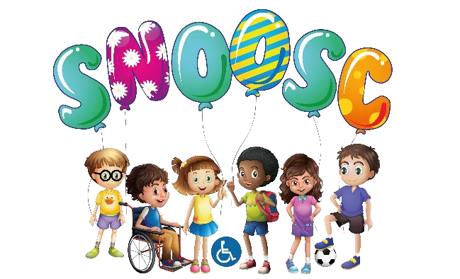

JOB DESCRIPTION

JOB TITLE: TRUSTEE
RESPONSIBLE FOR: Setting the vision and strategic direction of the organisation, with a shared passion for continuous improvement and drive to make a positive impact on young lives.

PURPOSE OF ROLE:
SNOOSC is a dynamic, forward thinking, empathetic Charity that provides support to disabled young adults/children and families in Bedfordshire. The role of a trustee as a representative of the community is to be the main force pressing the organisation to the realisation of its opportunities for service and the fulfilment of its objectives to the organisation’s users, staff, volunteers, funders and wider community.
DUTIES & RESPONSIBILITIES:
The role of a trustee is to work as part of a trustees’ team, overseeing the organisation’s operations, approving policies and procedures and ensuring that office staff and workers are adhering to them. It is also to oversee and approve financial and managerial plans, moving the organisation forwards, enabling SNOOSC to continue to reach out to the community and help the families in need.
At its simplest, the role of the trustee board is to receive grant funding, safeguard them and apply them to the charitable purposes of SNOOSC. The trustee board must always act in the best interests of SNOOSC, exercising the same standard of duty of care that a prudent person would apply if looking after the affairs of someone for whom they have responsibility. The trustee board must act as a group and not as individuals.
Trustees are to have experience in working at senior or Board level, providing strategic leadership during times of change, the ability to analyse information and prepare well for Board meetings is crucial to making an impact, to provide candid and constructive criticism, advice, comments and praise. A Trustee Has vision, enthusiasm, and excellent communication and interpersonal skills – the ability to influence Board decisions, challenge and support the Executive team. Committed to SNOOSC, fully supporting our charitable object and focus on young people, trustees are ambassadors for SNOOSC and its visitors, guests, members and volunteers.
A trustee might need to undertake additional training as required and take a positive approach to personal development.

17 Apex Business Centre, Boscombe Rd, Dunstable LU5 4SB
Telephone: 01582 868 244 Email: snoosc1@gmail.com
Registered Charity: 1098448

PERSON SPECIFICATION:
Each trustee must have:
- a commitment to the mission of SNOOSC
- a willingness to meet the minimum time requirement
- integrity
- strategic vision
- good, independent judgement
- an ability to think creatively
- a willingness to speak their mind
- an understanding and acceptance of the legal duties, responsibilities and liabilities of
- trusteeship
- an ability to work effectively as a member of a team and to take decisions for the good
The board of trustees collectively needs skills and experience in the following areas:
- financial management, income generation and enterprise
- public policy and public affairs
- national and local voluntary sector
- national and local government and statutory bodies
- digital strategy
- trading subsidiaries and social enterprise
- human resource management
- volunteering management and brokerage
- funding/foundations
- collaborative partnerships
- social investment and impact
TEAM ETHOS:
SNOOSC is a small organisation and depends on a team ethos, shared approach and positive relationships on all levels.
Work effectively as a team, supporting other team members and being willing to receive support whilst fulfilling your own responsibilities and tasks.
Ensure good communications and relationships within the team at all times. Attend team meetings, personal appraisals and task group meetings proactively and as a contributor.
SNOOSC is a Charity and relies heavily on fundraising for the organisations income. Staff are encouraged to support occasional fundraising events and if possible engage their own people networks in gaining support for the Charity.

17 Apex Business Centre, Boscombe Rd, Dunstable LU5 4SB
Telephone: 01582 868 244 Email: snoosc1@gmail.com
Registered Charity: 1098448

