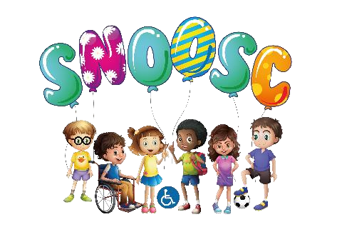

SNOOSC (IN BEDS) FEEDBACK FORM
Please complete the feedback form. Your input is very useful in helping SNOOSC improve their services.
Child Name: _____________________ Age:____________

Gender: (Please circle) Male Female

Where do you live? (Please circle)
Bedford borough Central Bedfordshire Luton borough

How long has your child been accessing SNOOSC (IN BEDS)? __________________
What sessions does your child access? (Please circle)

After school club Saturday club Holiday club

How beneficial do you find the SNOOSC short breaks service:
___________________________________________________________________________ ___________________________________________________________________________
___________________________________________________________________________
Since your child has been attending SNOOSC (IN BEDS) have you noticed your child making progress in the following?
Self Esteem | Communication Skills | Self Help Skills
Confidence | Relationship Skills | Transitioning
Social Activities | Independence | Behaviour
Other (Please specify)

What activities does your child enjoy doing at SNOOSC? (Please circle as many as you like)
Swimming Bowling Canal boat Bike riding
Arts and Crafts Workshops Watching DVDs Flower workshops Magic shows
Cinema/Theatre shows Cooking workshops Stockwood Park Whipsnade Zoo
Soft play/bouncy castle Dance/music Sports workshops Sing-Alongs
Apex Business Centre, Boscombe Rd, Dunstable LU5 4SB
Telephone: 01582 868 244 Email: snoosc1@gmail.com Registered Charity: 1098448

We would appreciate any suggestions or any ideas on any other activities that your child would enjoy.
___________________________________________________________________________
___________________________________________________________________________
___________________________________________________________________________
If your child attended the Summer Scheme, what were your thoughts on the activities provided:
___________________________________________________________________________ ___________________________________________________________________________
___________________________________________________________________________

Would you like to be informed of future community fundraising activities and to become involved in some of them?
___________________________________________________________________________
___________________________________________________________________________
___________________________________________________________________________

Facilities and staff at SNOOSC (IN BEDS)
Below is a list of statements, please circle whether you agree or disagree

The sessions are well organised Agree Disagree

The activities are appropriate to the young people’s needs. Agree Disagree

The activities arranged seem to be enjoyed by my child Agree Disagree

I believe that the sessions are beneficial for my child Agree Disagree

The staff and volunteers are friendly and helpful Agree Disagree

Final Comments
Could you please share with us any other comments you would like to include in this
Feedback Form
___________________________________________________________________________
___________________________________________________________________________
___________________________________________________________________________ ___________________________________________________________________________
___________________________________________________________________________
THANK YOU FOR COMPLETING THIS FEEDBACK FORM!

Apex Business Centre, Boscombe Rd, Dunstable LU5 4SB
Telephone: 01582 868 244 Email: snoosc1@gmail.com Registered Charity: 1098448

