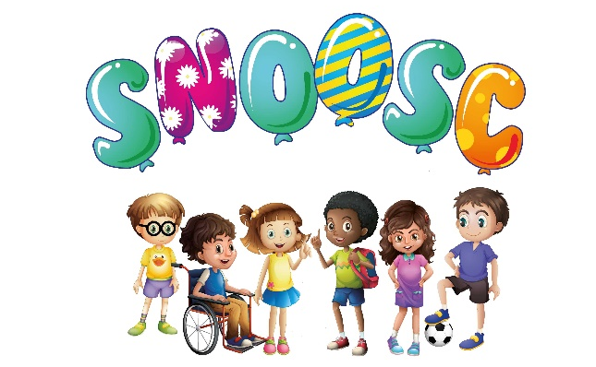

JOB TITLE: VOLUNTEER
RESPONSIBLE TO: TEAM LEADER/DEPUTY TEAM LEADER/MANAGEMENT/TRUSTEES
RESPONSIBLE FOR: SUPPORTING OTHER WORKERS AND SUPERVISION OF CLUB MEMBERS
HOURS OF WORK:
ALTERNATE SATURDAYS 9.30AM - 4.30PM
SCHOOL HOLIDAYS 9.30AM - 4.30PM ALL SCHOOL HOLIDAYS
PURPOSE OF ROLE:
SNOOSC is a dynamic, forward thinking, empathetic Charity that provides support to disabled young adults/children and families in Bedfordshire. The role of a Buddy is vital for the smooth running of the club sessions, where team members will help provide valuable support interaction and play opportunities for club members and their families.
DUTIES & RESPONSIBILITIES:
Interaction, Play Communication, Social Interaction; To offer diverse, safe and stimulating activities to club members of all ages and abilities whilst at SNOOSC club sessions.
There will be pre-programmed activities and trips in which Volunteers will be expected to encourage participation (such as sports, arts and crafts, music sessions, and story -telling). All Volunteers are required to use their initiative during activities whilst observing Health & Safety Policy & Procedures.
Volunteers are required to show enthusiasm, patience, creativity, good communication skills (with colleagues, families and club members), resourcefulness, diplomacy, honesty, and a commitment to young people/children’s play and development.
To have a pleasant manner, maintain good relationships with other staff members. All Volunteers must ensure that they understand the varied needs of the young adults/children from different cultural and family backgrounds and with different disabilities
ALL staff must maintain confidentiality towards service users and SNOOSC organisation at all times - including when out of work hours and on social media.
GENERIC DUTIES & RESPONSIBILITIES:
All Volunteers are to work as part of the team to ensure a safe and secure, but friendly creative and stimulating environment for club members and for all staff/volunteers during sessions.
To ensure that toys, equipment and venue is maintained in a clean and tidy manner both during the day and at the close of session. This may include setting up and packing away.
Volunteers are required to adhere to risk assessments and giving clear accurate records in the case of any accident, incidents and any others information required on the same day.
All Volunteers are required to undertake other tasks as and when required, including Intimate Care, when asked by the Team Leader/Deputy Team Leader, the only exception will be for religious reasons.
CARE - ALL SESSIONS:
After induction Volunteers will be allocated after induction to a one to one care with club members, and must stay with the allocated club member unless authorised by the Team Leader/Deputy Team Leader for a change or any other task, in a safe and enjoyable environment during all sessions. All care must be provided in a safe and enjoyable environment during all sessions.
To participate in the organisation of play activities on a one to one basis with the designated club member during the course of the day. Assist the club member during meal times along with moving and handling if needed.
Volunteers will be required to familiarise themselves with the designated club members needs before opening of the session (through profile forms such as BMPs/SSPs) and must take into consideration such needs whilst supervising the club member on a one to one basis during the course of the session.
POLICIES & PROCEDURES:
The post holder must ensure that they read and familiarise themselves, to know and comply with SNOOSC policies and procedures.
To ensure that the premises, rules and regulations are adhered to at all times whilst at work with occasional trips and activities at other locations and sites.
To promote and foster the reputation and standing of SNOOSC at all timed and to support the rest of the team in doing the same.
Fulfil the duties and responsibilities of an employee as regards Health and Safety at Work, including own safety and self-management.

TRAINING & DEVELOPMENT:
1) Safeguarding
2) Child Protection
3) Manual Handling
Undertake additional training as required and take a positive approach to personal development (such as Intimate Care, Fire Safety, Medication awareness etc).
Please note that required training will be free of charge, although this is to be referenced with SNOOSC training form to be signed before training.
TEAM ETHOS:
SNOOSC is a small organisation and depends on a team ethos, shared approach and positive relationships on all levels.
Work effectively as a team, supporting other team members and being willing to receive support whilst fulfilling your own responsibilities and tasks.
Ensure good communications and relationships within the team at all times. Attend team meetings, personal appraisals and task group meetings proactively and as a contributor.
SNOOSC is a Charity and relies heavily on fundraising for the organisations income. Staff are encouraged to support occasional fundraising events and if possible engage their own people networks in gaining support for the Charity.
PLEASE NOTE EMPLOYMENT IS SUBJECT TO:
A SATISFACTORY ENHANCED DISCLOSURE AND BARRING SERVICE (DBS) CHECK 2 SATISFACTORY REFERENCE CHECKS, 1 OF WHICH MUST BE FROM YOUR MOST RECENT EMPLOYER OR PLACE OF STUDY.

