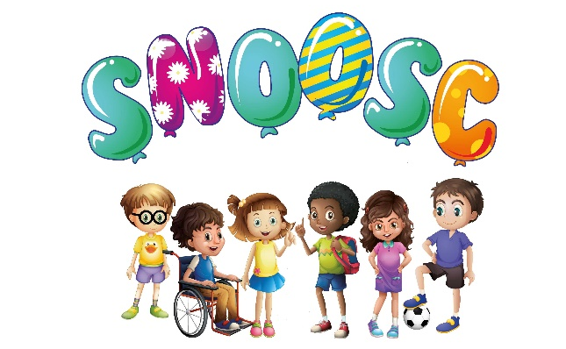

S.N.O.O.S.C.

CHARGING & CANCELLATION

POLICY

Special Needs Out of School Club offers a Short Breaks/Respite facility for Families who have children and young adults with disabilities including challenging behaviours. This also offers Short Breaks for Parents/Carers and enables them time to spend with other family members of the family and siblings.

This service is heavily subsidised by charitable contributions, stakeholders and funders. The organisation offers the following charges, which are giving excellent value for money. However, SNOOSC reserve the right to change the amount for Fees/Parental Contributions charged at any time, with a prior notice of 4 weeks in writing informing Parents/Carers and the Local Authority. Siblings that attend sessions (that meet the requirements, of the SNOOSC organisation) are charged at the same rate.

This also includes a change of Venue, hours of Saturday and Holiday Club sessions, however SNOOSC will endeavour to inform Parents/Carers as soon as is practical should there be the need for a change of Venue.

Payment is required for Parental Contributions at the time of booking (new booking system, including on-line website booking from January 2021) Local Authority funded families will be paid by invoice, for ALL applicable SNOOSC services.

For families encountering difficulties, a payment plan can be arranged and agreed, in the strictest confidence with the SNOOSC Manager. The organisation does not wish any family under these circumstances to find themselves unable to access any service and specialisms offered. However, ALL families will be encouraged to approach the Local Authority for placement on the Disabilities Register. This can be completed on-line, and to also approach the Local Authority for Assessments/Care plans.

SATURDAY CLUB: 10.00 am - 4.00 pm: (Half day – 10.00 am – 1.00 pm (Morning) 1.00 pm - 4.00 pm) (Afternoon):

A fee is charged at the rate of £10.50 p per hour. Therefore a 6 hour session per day is charged at the rate of £63.00p. A 3 hour session per half day is charged at the rate of £31.50p.

Any Parents/Carers requesting half day sessions, the fees will be adapted accordingly

There are no Transport arrangements for Saturday Club:
Parents/Carers will be responsible for bringing their child/young adult to the sessions and will be responsible for collecting them at the end of their allocated time.

Additional fees may be payable for extra off-site activities, the organisation reserves the right from time to time at the discretion of SNOOSC Management/Trustees.

HOLIDAY CLUB: 10.00 am – 4.00 pm: (Half day – 10.00 am – 1.00 pm (Morning) 1.00 pm – 4.00 pm) (Afternoon):

Please Note: There are no half day sessions should a full day trip be booked:
Start time should a trip be booked 9.30 am – 4.00pm: (however collection time may be later if a trip has been pre-arranged). Parents/Carers will be informed accordingly.

A fee is charged at the rate of £10.50p per hour. Therefore a 6 hour session per day is charged at the rate of £63.00p. A 3 hour session per half day is charged at the rate of £31.50p.

Any Parents/Carers requesting half day sessions, the fees will be adapted accordingly.

There are no Transport arrangements for Holiday Club:
Parents/Carers will be responsible for bringing their child/young adult to the sessions and will be responsible for collecting them at the end of their allocated time.

Additional fees may be payable for extra off-site activities/trips, the organisation reserves the right from time to time at the discretion of SNOOSC Management/Trustees.

CANCELLATIONS & NON-ATTENDANCE:

Places are sometimes booked many weeks in advance. It is therefore appropriate for the SNOOSC organisation to have a cancellation clause. If a place is cancelled 4 weeks or more before any sessions, a FULL REFUND/CREDIT will be issued.

If the cancellation is less than 4 weeks, but more than 7 days A FULL CREDIT will be issued. Should the cancellation be less than 7 days (owing to the organisation engaging and booking staff to work with club members on a 1 : 1 basis) there will be NO CREDIT/REFUND issued by the SNOOSC organisation.

Funded Children, the SNOOSC organisation will inform the Local Authority of any cancellations, and circumstances involving the cancellation should there be any known, as soon as is practicable.

Should a child/young adult not attend a booked session, less than 7 days prior to the session (owing to the organisation engaging and booking staff to work with club members on a 1 : 1 basis). There will be NO CREDIT/REFUND unless it is found that a child/young adult has been hospitalised, then a CREDIT/REFUND will be issued. Proof of this will be required.

Pandemic circumstances – should there be a need for self-isolation for club members, with reference to a positive result, proof via email will be needed, a credit/refund will be applied, should the club member be booked into session during the isolation period. Should a member of the household receive a positive result, and the need for the club member to self-isolate, the same terms will apply.

Funded Children, the SNOOSC organisation will inform the Local Authority of any non-attendance, and circumstances involving the non-attendance should there be any known, as soon as is practicable, on the next available working day.

It is at the discretion for the SNOOSC Board of Trustees to alter, change, any reference or content within this Policy.

This Policy is referenced to Admissions Policy/Starter Pack for Parents/Carers.

Policy reviewed February 2022:

This Policy to be reviewed February 2024:

