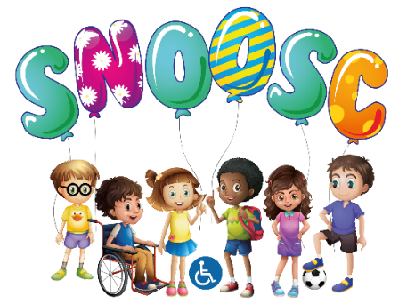

S.N.O.O.S.C.

CHILD PROTECTION POLICY

Special Needs Out Of School Club will endeavour to provide an environment where children are kept safe from injury and abuse, in a happy, safe and secure environment.
All staff and Volunteers have a responsibility for the welfare and safety of the children and young adults who attend the Special Needs Out Of School Club. Because of their learning difficulties, Disabilities & Challenging Behaviours that Special Needs Out Of School Club members have in communicating their experiences to adults it is particularly important for staff to be vigilant regarding child protection issues. Staff will need to use their knowledge of individual young person through the SNOOSC SSP to identify changes in mood and behaviour, which may be signals of a child protection issue. They are advised to discuss with the designated member of the management team any observations however minor, which they believe may be cause for concern.
The designated person for Child Protection at Special Needs Out Of School Club is The Manager.
Steps will be taken to assess and monitor the suitability of staff and volunteers working with children and to support staff to keep the children safe.
All applicants will be asked to complete a Disclosure Application Form and provide 2 references; these will be followed up prior to the commencement of employment.
Wherever possible no volunteer or member of staff will work alone with a child, until the DBS has been completed, and suitability to work on a 1 : 1 staff ratio with a club member.
If staff or volunteers have cause for concern about the welfare of a child their concerns should be reported to the Manager. The matter should not be discussed with any other person. Every concern expressed will be noted to identify any pattern, which may emerge. The co-ordinator will monitor the Incident books and note any patterns and links between incidences. They will then notify the Manager. Any serious concerns must be shared with the club members Social Worker, should they have one..
When suspected abuse has been identified a written report will be prepared and the incident reported to the duty desk at Social Services Disability Team, or in the case of a young person over 18 The Adult Learning Disability Team, under 18 the CWD Team – Children with Disabilities Team.
The management will notify the Social Services duty team who will advise what if any action will be taken. Details including the name of the Social Services official will be recorded.

Any observation, which may relate to the following areas of possible abuse, should be brought to the attention of the designated person only. They should not be discussed with any other person.
- Neglect:
Neglect is the persistent failure to meet a child’s basic physical and/or psychological needs, likely to result in the serious impairment of the child’s health or development. Neglect may involve a parent or caregiver failing to: Provide adequate food, clothing or shelter including exclusion from home or abandonment. Protect a child from physical and emotional harm or danger. Ensure adequate supervision including the use of inadequate caregivers. Ensure access to appropriate medical care or treatment. It may also include neglect of, or unresponsiveness to a child’s basic emotional needs.
- Physical Abuse:
Physical abuse may involve hitting, shaking, throwing, poisoning, burning or scalding, drowning, suffocating, or otherwise causing physical harm to a child. Physical harm may also be caused when a parent caregiver fabricates the symptoms of, or deliberately induces, illness in a child.
- Sexual Abuse:
Sexual abuse involves forcing or enticing a child/adult into sexual activities, including prostitution, whether or not the child is aware of what is happening. This may include non-contact activities, such as involving children looking at, or in the production of sexual on-line or printed images, watching sexual activities, or encouraging children to behave in sexually inappropriate ways.
- Emotional Abuse:
Emotional abuse is the persistent emotional maltreatment of a child so as to cause severe and persistent adverse effects on the child’s emotional development. Some level of emotional abuse is involved in all types of maltreatment of a child, though it may occur alone. Parents/caregivers of children with multiple needs may find it difficult to ensure that the full range of their needs, including their emotional needs, is met. It may be hard to include such children in everyday activities alongside other family members, but not to include them may be harmful over an extended period of time.
If concerns are raised about the behaviour/approach of individuals assisting at the Out Of School Club these will be noted, discussed by Management and appropriate action taken. Where such an individual was supplied by an agency, the agency and Social Services will be informed of any concern.
Staff need to be aware of the current climate with regard to physical contact with the young people that use our club on behalf of themselves and their colleagues. It is recognised however that for some children and young adults physical contact will form part of their leisure and care programme and that there will also be occasions when a child will need to be physically comforted if in distress.

Staff to be vigilant and aware to any signs of the following:-

Rough, physical or sexually provocative games, including horseplay.
Share a room with a child.
Allow or engage in any form of inappropriate touching.
Allow children/adults to use inappropriate language unchallenged.
Make sexually suggestive comments to a child/adult even in fun.
Reduce a child to tears as a form of control.
Any allegations made by a child/young adult must at all times be addressed.
Do things of a personal nature for children or disabled adults that they can do for themselves.
Invite or allow children to stay with you at your home unsupervised.
To keep a check and records on visitors, guests whether their visit is by invitation or unsolicited

STAFF TRAINING
The designated persons to keep up to date with current practice in child protection procedures and to further develop skills in identification of possible abuse will undertake training. Other members of staff will be trained by the designated persons or attend courses when available.

Referenced with Safeguarding Policy/Risk Assessment/Vulnerable Adults/Health & Safety Policies:
This Policy reviewed February 2022:
This Policy to be reviewed February 2024:

