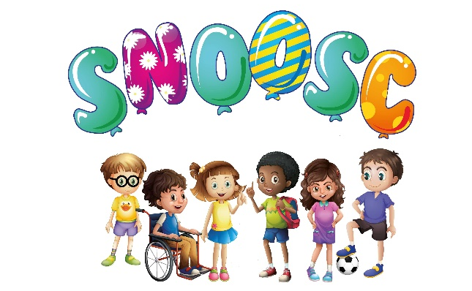
S.N.O.O.S.C.
PRIVACY POLICY
General Data Protection Regulation:
Privacy Notice:
BACKGROUND:
Special Needs Out of School Club (in beds) - SNOOSC is committed to protecting the privacy and security of your personal information.
This privacy notice describes how we collect and use personal information about you during and after access to SNOOSC services, in accordance with the General Data Protection Regulation (GDPR).
It is important that you read this notice when we are collecting or processing personal information about you, so that you are aware of how and why we are using such information.
DATA CONTROLLER:
SNOOSC is a “data controller”. This means that we are responsible for deciding how we hold and use personal information about you. We are required under data protection legislation to notify you of the information contained in this privacy notice.
DATA PROTECTION PRINCIPLES:
We comply with data protection law. This says that personal information we hold about you must be:
1) Used lawfully, fairly and in a transparent way.
2) Collected only for valid purposes that we have clearly explained to you and not used in any way that is incompatible with those purposes.
3) Relevant to the purposes we have told you about and limited only to those purposes.
4) Accurate and kept up to date.
5) Kept only as long as necessary for the purposes we have told you about.
6) Kept securely.
THE KIND OF INFORMATION WE HOLD ABOUT YOU:
Personal data, or personal information, means any information about an individual from which that person can be identified.
It does not include data where the identity has been removed (anonymous data). There are also “special categories” of more sensitive personal data which require a higher level of protection.
We will collect, store and use the following categories of personal information about you.
Parent/Guardian Information:
Personal contact details such as name, telephone number, mobile number, email address and school that your child attends, next of kin and relationship to the club member. Permission to use pictures/images/video recordings, of your child/young adult. Information relative for SNOOSC BMP (Behaviour Management Plan). Relevant for access to the SNOOSC organisation services.
Child Information:
Personal information such as name, gender, date of birth. Medical conditions, emergency contact details, special needs, disabilities, allergies, epipen status, supported by medical reports and diagnosis, if any, parent details, ethnicity. Relevant for access to the SNOOSC organisation services.
How is your Personal information collected:
SNOOSC collects information from application forms (registration), from Parents/Guardians over the telephone and via email, including “face to face” interviews during registration. This also includes signed and dated declarations permitting use of pictures/images/video recordings.
Child Information:
SNOOSC collects personal information which Parents/Guardians provide about their child/young adult, as above.

How we will use information about your child/young adult:
SNOOSC may use the information with the Local Authorities relevant to the area that they live (this is usually for funding purposes). Data used for third parties (although no personal names, will be used in this instance). Information shared with the School, and Professionals only where necessary. Pictures and images and video recordings used for SNOOSC Facebook, SNOOSC website, and Local Authorities, and third parties (only with the permission from the Parents/Guardians).
Data Retention:
SNOOSC will only retain your personal information for as long as necessary to fulfil the purposes we collected it for, including for the purposes of satisfying any legal, accounting, audit trail or reporting requirements. To determine the appropriate retention period for personal data, we consider the amount of time, nature and sensitivity of the personal data, the potential risk of harm from unauthorised use and the applicable legal requirements.
Right of Access, Correction, Erasure:
It is important that the personal information SNOOSC holds about you your child/young adult is accurate and correct at all times. Please keep us informed if your personal information changes during your child/young adults duration with SNOOSC.
Request Access:
Under certain circumstances you have the right to:
Request access to your personal information (commonly known as a “data subject access request”). This enables you to receive a copy of the personal information we hold about you your child/young adult.
Information about children may be released to a person with parental responsibility. However the best interests of the child will always be considered.
Data Protection Officer:
SNOOSC have appointed a data protection officer to oversee compliances with this privacy notice. If you have any questions about this privacy notice or how we handle your personal information, please contact:-
Name: Kirsty Hunt
Contact Details: 01582 868244
Organisation Name: Special Needs Out of School Club (in Beds) SNOOSC:

Changes to this Privacy Notice:
SNOOSC reserves the right to update this privacy notice at any time and without notice:
Date of Issue 25th May 2018

Referenced with GDPR/Data Protection Policies:

Policy reviewed April 2022:

This Policy is to be reviewed April 2024:

